AI in Fintech Application

Three Use Case of AI in Fintech
As per the research, here are the top areas where AI technologies are creating never-before improvements in business operations for FinTech:
- Fraud Detection & Prevention
- Credit Risk Analyser
- Client Risk Profiling




Fraud Detection & Prevention

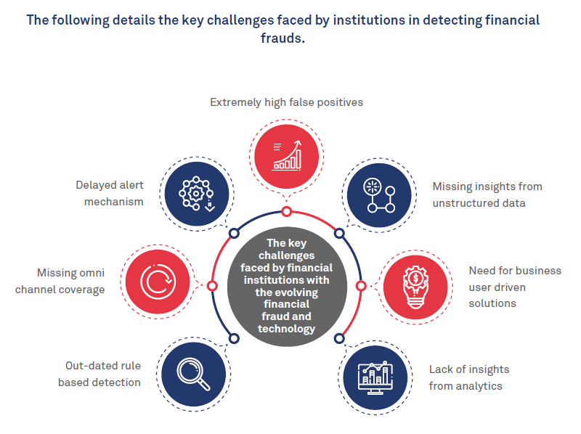
Banks could benefit from a machine learning-based fraud detection solution in that they would be able to instrument it across more than one channel of data to be analysed. This would mean the model could be trained to detect fraud within more than one type of transaction or application, or both of these at the same time.
Machine learning models for fraud detection can also be used to develop predictive and prescriptive analytics software. Predictive analytics offers a distinct method of fraud detection by analyzing data with a pre-trained algorithm to score a transaction on its fraud riskiness.
Prescriptive analytics takes the predictions made from the correlations of a predictive analytics engine and uses it to provide recommendations for what to do once fraud is detected.

Credit Risk Analyser
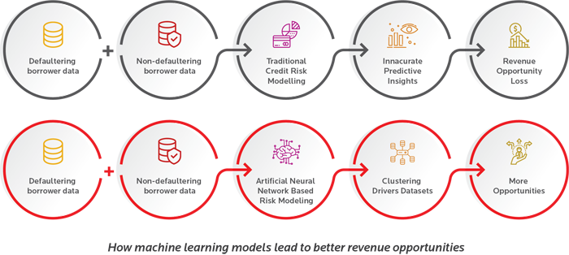
For banking majors, credit risk has always been a challenging area, given the multiple factors that go into forming an individual’s risk profile. For business borrowers, the process is even more complicated as data across a variety of parameters and time periods must be aggregated and analyzed to create a holistic picture of risk.
Assigning a credit rating to any company involves sizeable investments, time, and expertise. Typically, banks would employ specialized credit rating agencies to conduct a rigorous evaluation based on financial as well as non-financial indicatives.
And the stakes are extremely high for lending banks -- inaccurate assessments can cost organizations sizeable amounts. This is further intensified by sub-optimal underwriting, inaccurate portfolio monitoring methodologies, and inefficient collection model.
An ML model, like the Artificial Neural Network, would create discrete clusters of datasets and apply merging methodologies to figure out if a specific customer should be offered a loan. Instead of merely looking at the mean values, ML creates majority and minority clusters and merges them to create a diverse dataset, reflecting the real on-ground picture.
Client Risk Profiling
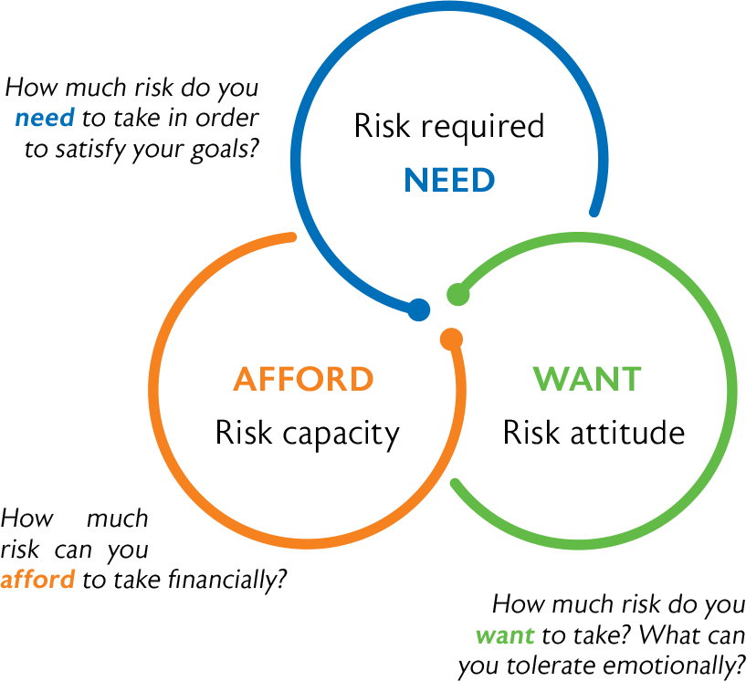
Most reputable financial planners, locally and abroad, start with an assessment to assess a client’s attitude to risk. The rationale behind this is that although each investor is unique, it is possible to categorise clients’ attitudes to risk using proven psychometric profiling techniques.
From a goals-based financial planning point of view, a client should be at the centre of every disclosure. In order to enable a client to make an informed decision, all relevant and material disclosures about investment risk and the risk taken need to be provided. Hence client education on investment planning and risks is crucial.
Explaining various risks to clients helps them to gain a better understanding of the risks of investing. This includes shortfall risk – failing to meet goals – or, in its simplest form, that the value of his investments may decline over a given period, as well as explaining that the investment is exposed to downside risk. These concepts need to be quantified in simple and understandable terms.
Financial planners also have a duty to provide advice with due skill, care and diligence. Therefore, they need to caution a client if risks taken or agreed on, are not suitable considering all the information collated from the client and the subsequent outcome of the overall assessment.
Lastly, client information and the risk profiling analysis need to be properly documented in the advice process. The record of advice furnished to the client must reflect the basis on which the advice was given. Ultimately, the final decision rests with the client and it is imperative that any deviations from the recommendations made by the financial planner should be kept on record. 

